How to vote on a ballot
- Login on the www.arema.org site then click Member Home. From there, click on My Communities to be directed to the Communities site.

- Click on Communities at the top of the page and then click My Communities to select the committees you are on.

- Navigate to your Committee Community and click on Workspace.

- Click on Ballots. You will see the open Ballots available for you to vote on.
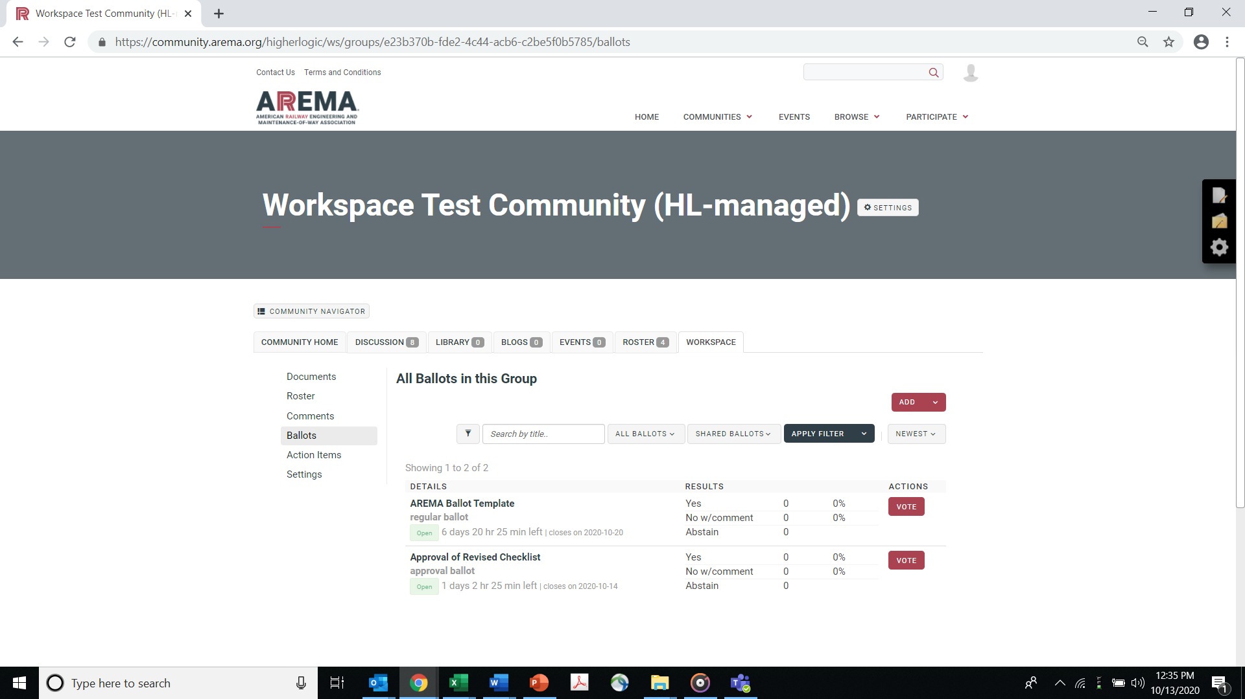

- Under Actions, click VOTE for the Ballot you want to cast your vote on.

- Review the question and any Referenced Items which will be the documents for approval. To view the Referenced Items, scroll down to Reference Items and click Download.

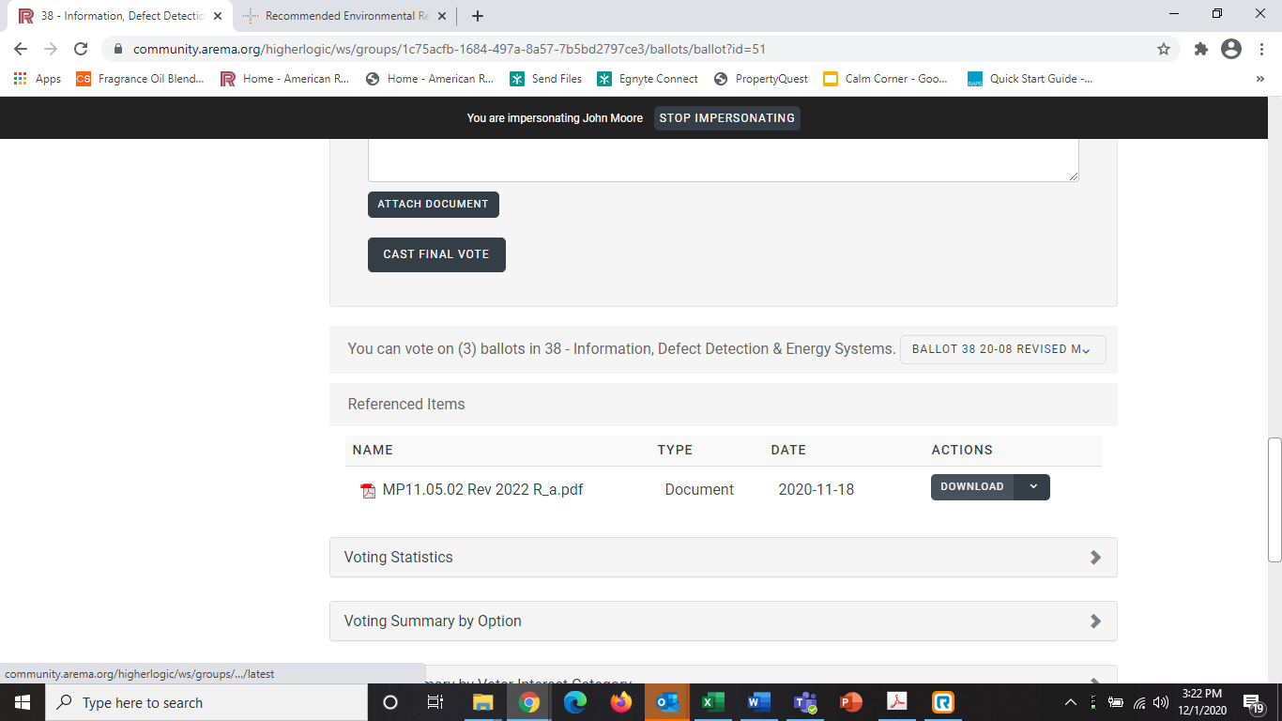

This will open up the Referenced Items in a new tab in your browser.

- After review of the Referenced Items, Cast Your Vote. Comments are required for “No” votes and optional for other options.
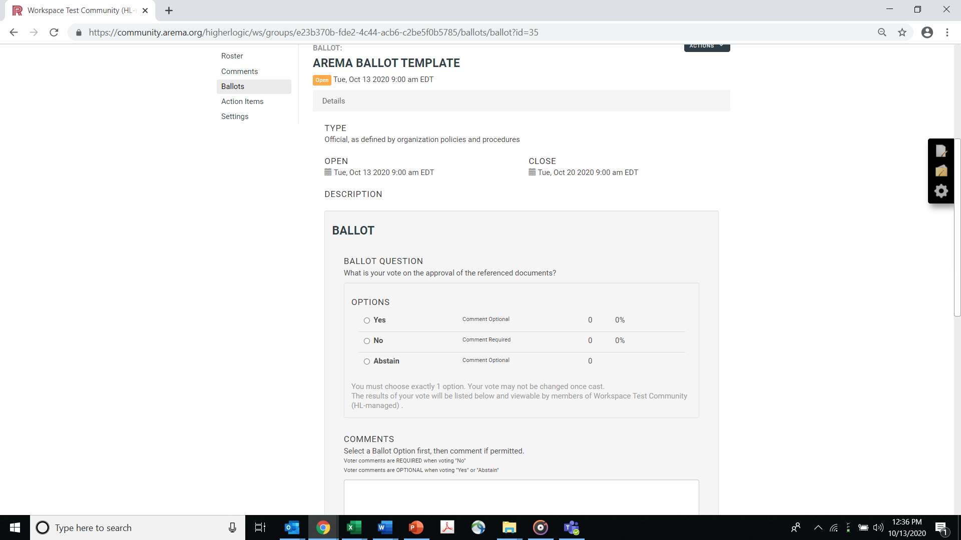

- Should you need to, after voting you will have the option to Change your vote. To change your vote, click on Ballots and select the ballot you would like to change your vote on and click Revote.

