Getting Started on the AREMA Community

Make the most of your AREMA Community experience by taking these steps to connect and engage with others on topics that are important to you. Committee members may also take care of any Committee activities.

Step 1: Log in

Go to www.arema.org > Member Home. Click My Communities to be directed to the new AREMA Community homepage. Here you will see any recent activity in the Communities you belong to. Please note that upon initial login, you will have to accept the “Terms and Conditions” to use the community platform.

Step 2: Set up your profile

Click on the icon in the upper right corner to access your Profile page. Here you can update your personal information and upload a picture. However, if you have an address or email change, please do so through your online profile on the main AREMA website. Through the My Connections tab you can add and request to add Contacts. While you are on your Profile, you will also want to set your email preferences.

Step 3: Set up your email preferences

You will want to stay in touch with your AREMA community so adjust your email preferences to meet your need. To adjust your email preferences, click on My Account > Email Preferences. The default is set to “Daily Digest” for a single email each day summarizing the topics in your community or stay informed in real time with instant alerts through “Real Time Updates.” Now that your preferences are set, it is time to explore your communities.

Step 4: Check out your new Communities homepage

Click on Home for an overview of activity in your AREMA Communities. Here you will see:
Recent Activity
Unanswered Posts
Upcoming Events

On the right side of the page are Quick Links so you can quickly access Resources, Discussion Items, and Your Communities. Take a few moments to familiarize yourself with this page.

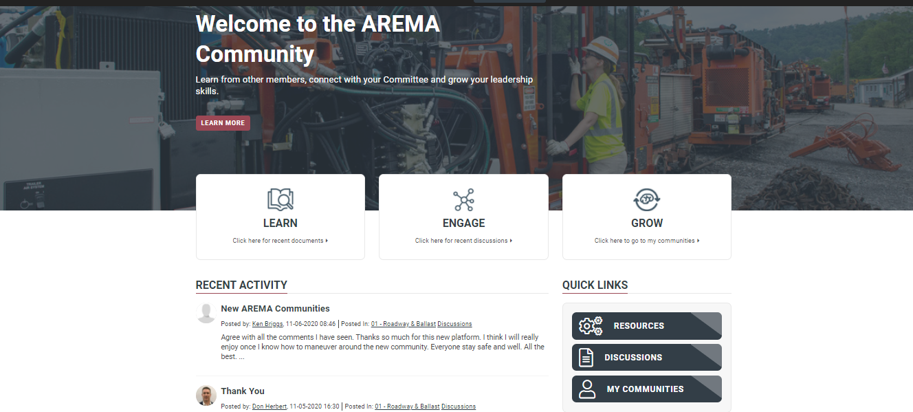

Step 5: Explore your Communities

Click on My Communities, either from the Quick Links or the top of the page. This will take you to the landing page for the Communities you are a member of.

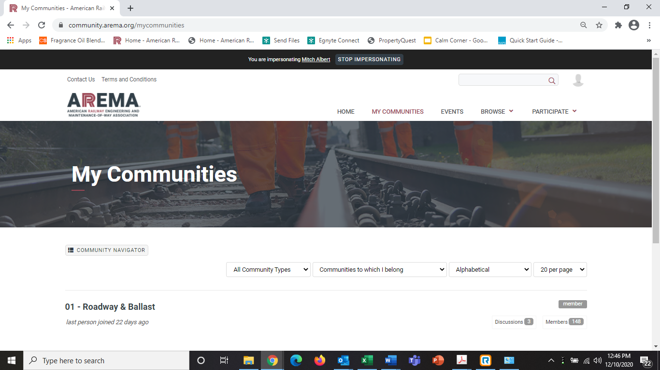

You will be able to post discussion items and review documents. Committee members may also take part in manual material development and vote on their Committee page.
Let us explore some of the options in your Communities.

Step 6: Take part in a discussion
Engage with your community through starting and replying to discussion items. To start a discussion, click on the Discussion tab and click Post New Message.
To take part in an existing discussion, click on the title under Thread Subject.

Step 7: Explore your resources
Documents are housed in the Library.

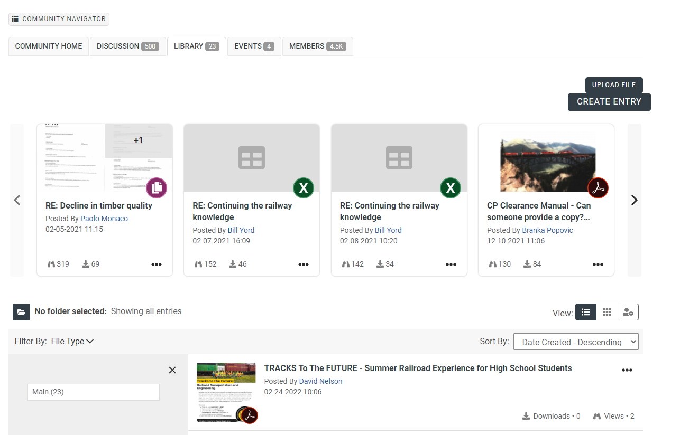

You can also contact other members of by sending a message through the Members tab. Click on Members and select the person you would like to reach out to.

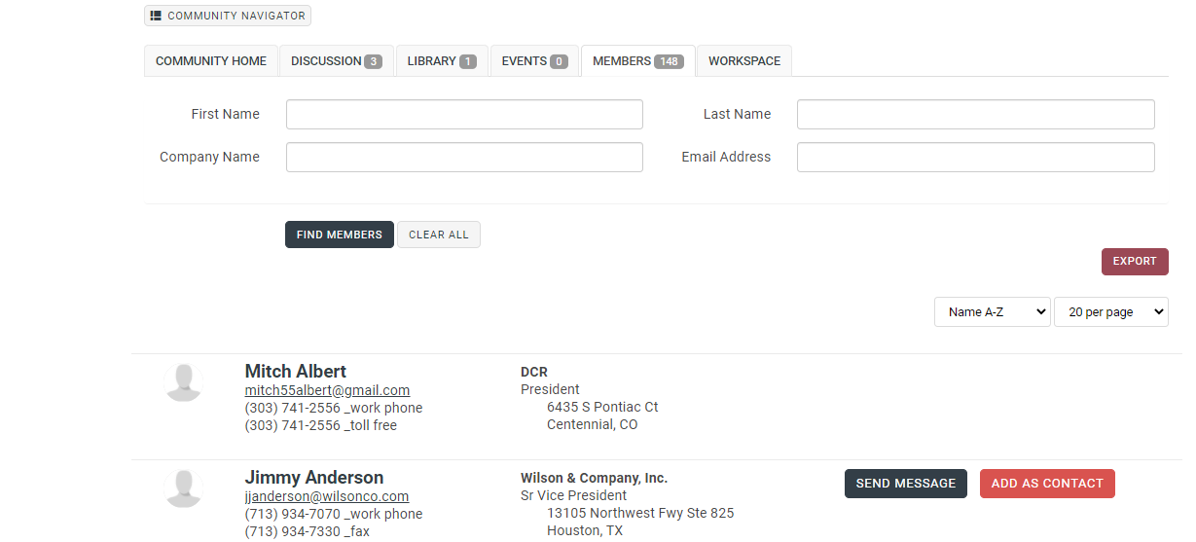

Click “Send Message” next to their contact information.

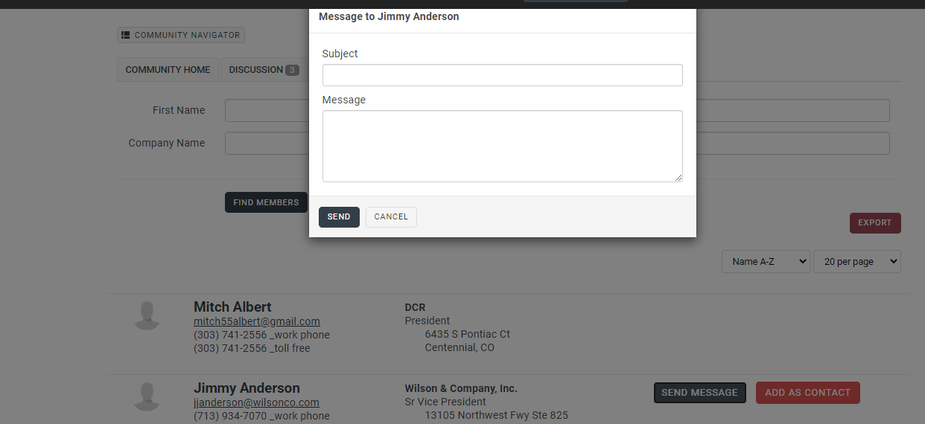
You can also add them as a Contact. Your Contacts will be listed under your Profile >>My Connections>>Contacts.

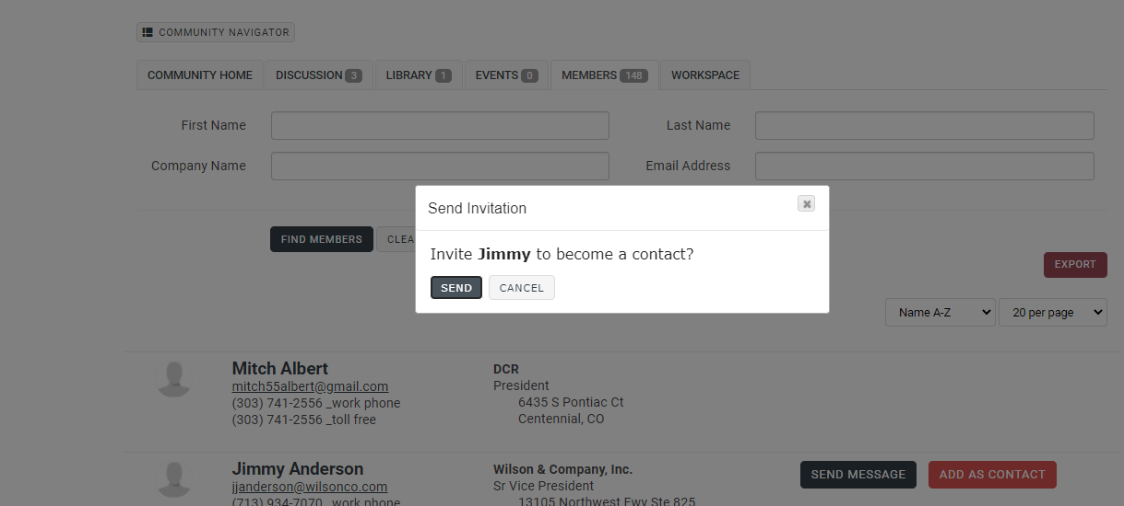
What next?
After you have familiarized yourself with the main site, Technical Committee members will want to explore Workspace where you can review documents up for approval and cast your vote. Separate instructions are available for balloting. All balloting is under the Workspace tab.

